horizontal line

**Delhi Technological University**

Department of Applied Physics

IVth Semester

**MICROPROCESSORS & INTERFACING**

**MPI EP - 206**

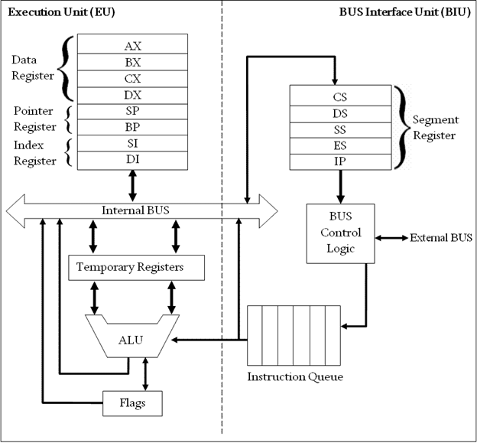

# **Submitted by :**

**ADITYA SINGH, 2K19/EP/005**

**Submitted to:**

**Dr. Rishu Chaujar**

# **Experiment 2**

**Multiplication of two 16-bit Numbers**

**THEORY**

1. Include the emu8086.inc library and start the data and code segments.
2. Input the first number into the AL register using the int 21h interrupt.
3. Subtract 48 (ASCII value of 0) form the AL register to convert the number into decimal from ASCII.
4. Store this number into the BL register.
5. Print a newline and return carriage to the new line .
6. Input the second number into the AL register and repeat step 3.
7. Multiply the two numbers using the code :

mul bl

which multiplies the contents of bl and al register and stores the product in

the ax register.

1. Add 48 to the product to convert it back to ASCII.
2. Repeat step 5 and print the product to the output screen.

**CODE**

include 'emu8086.inc'

.data

.code

main proc

print "Enter first Number: "

mov ah,01h

int 21h

sub al,48

mov bl,al

mov dl,10

mov ah,02h

int 21h

mov dl,13

mov ah,02h

int 21h

print "Enter second number: "

mov ah,01h

int 21h

sub al,48

mul bl

mov bl,al

add bl,48

mov dl,10

mov ah,02h

int 21h

mov dl,13

mov ah,02h

int 21h

print "Product : "

mov dl,bl

mov ah,02h

int 21h

main endp

end main

**OUTPUT**

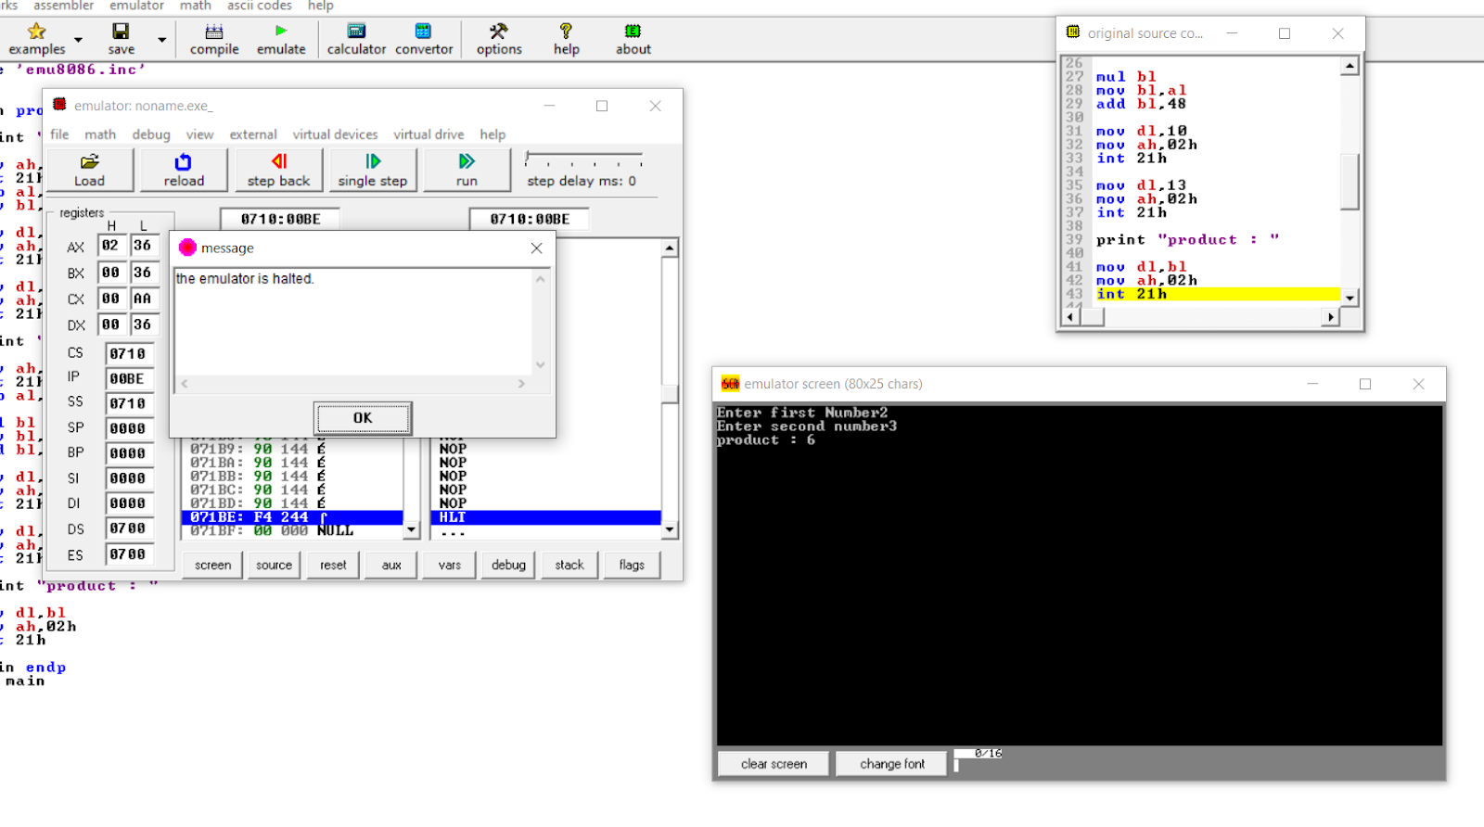

**END**